1. Min max

#include <stdio.h>

void findMinMax(int arr[], int low, int high, int *min, int *max) {

int mid, min1, max1, min2, max2;

if (low == high) {

*min = *max = arr[low];

return;

}

if (high == low + 1) {

if (arr[low] < arr[high]) {

*min = arr[low];

*max = arr[high];

} else {

*min = arr[high];

*max = arr[low];

}

return;

}

mid = (low + high) / 2;

findMinMax(arr, low, mid, &min1, &max1);

findMinMax(arr, mid + 1, high, &min2, &max2);

if (min1 < min2)

*min = min1;

else

*min = min2;

if (max1 > max2)

*max = max1;

else

*max = max2;

}

int main() {

int n, i, min, max;

printf("number of elements: ");

scanf("%d", &n);

int arr[n];

printf(" elements are : ");

for (i = 0; i < n; i++) {

scanf("%d", &arr[i]);

}

findMinMax(arr, 0, n - 1, &min, &max);

printf("Minimum element: %d\n", min);

printf("Maximum element: %d\n", max);

return 0;

}

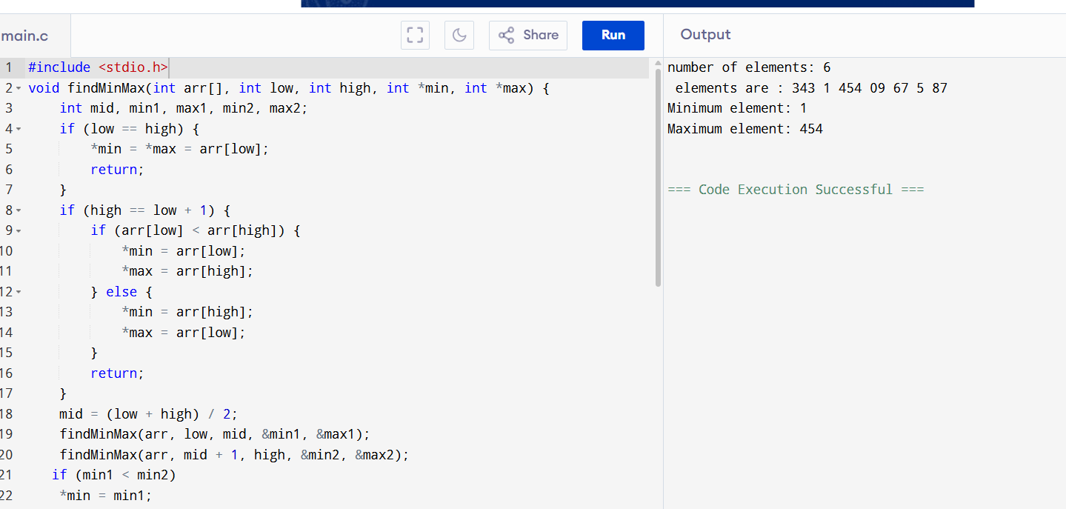

1. Hash table code

#include <stdio.h>

#include <stdlib.h>

#define SIZE 10

struct Node {

int data;

struct Node* next;

};

struct Node* hashTable[SIZE];

int hash(int key) {

return key % SIZE;

}

void insert(int key) {

int index = hash(key);

struct Node* newNode = (struct Node*)malloc(sizeof(struct Node));

newNode->data = key;

newNode->next = hashTable[index];

hashTable[index] = newNode;

printf("%d inserted \n", key);

}

void search(int key) {

int index = hash(key);

struct Node* temp = hashTable[index];

while (temp != NULL) {

if (temp->data == key) {

printf("%d found in hash table!\n", key);

return;

}

temp = temp->next;

}

printf("%d not found!\n", key);

}

void delete(int key) {

int index = hash(key);

struct Node* temp = hashTable[index];

struct Node* prev = NULL;

while (temp != NULL) {

if (temp->data == key) {

if (prev == NULL) {

hashTable[index] = temp->next;

} else {

prev->next = temp->next;

}

free(temp);

printf("%d deleted \n", key);

return;

}

prev = temp;

temp = temp->next;

}

printf("%d not found \n", key);

}

void display() {

for (int i = 0; i < SIZE; i++) {

printf("[%d] -> ", i);

struct Node* temp = hashTable[i];

while (temp != NULL) {

printf("%d -> ", temp->data);

temp = temp->next;

}

printf("NULL\n");

}

}

int main() {

int choice, key;

for (int i = 0; i < SIZE; i++) {

hashTable[i] = NULL;

}

printf("\n Hash Table Menu \n");

printf("1. Insert\n2. Search\n3. Delete\n4. Display\n5. Exit\n");

while (1) {

printf("Enter your choice: ");

scanf("%d", &choice);

switch (choice) {

case 1:

printf(" value to insert: ");

scanf("%d", &key);

insert(key);

break;

case 2:

printf(" value to search: ");

scanf("%d", &key);

search(key);

break;

case 3:

printf("value to delete: ");

scanf("%d", &key);

delete(key);

break;

case 4:

display();

break;

case 5:

printf("Exit\n");

exit(0);

default:

printf("Invalid choice\n");

}

}

return 0;

}

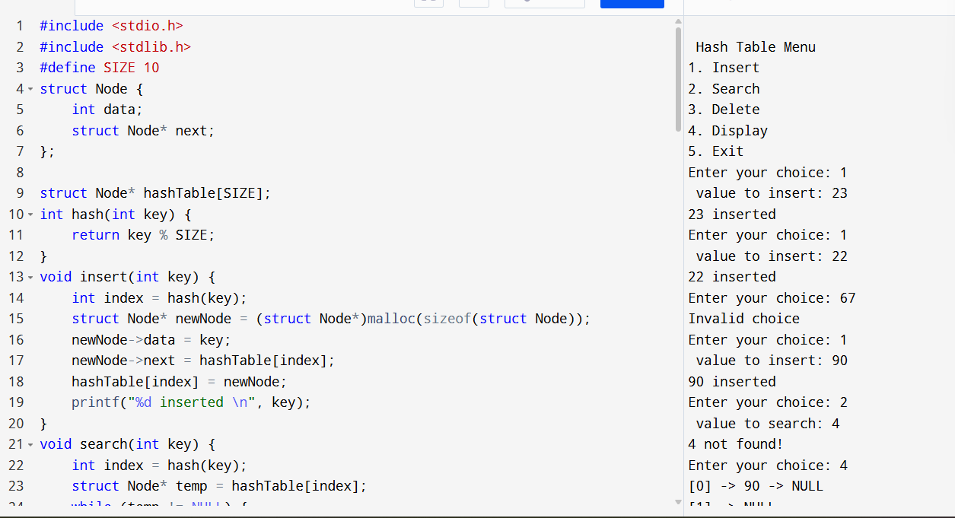

3-subarray

#include <stdio.h>

int max(int a, int b, int c) {

if (a >= b && a >= c) return a;

else if (b >= a && b >= c) return b;

else return c;

}

int maxCrossingSubarray(int arr[], int low, int mid, int high, int *cross_low, int *cross_high) {

int sum = 0;

int left_sum = -1000000;

int max_left = mid;

for (int i = mid; i >= low; i--) {

sum += arr[i];

if (sum > left_sum) {

left_sum = sum;

max_left = i;

}

}

sum = 0;

int right_sum = -1000000;

int max_right = mid + 1;

for (int i = mid + 1; i <= high; i++) {

sum += arr[i];

if (sum > right_sum) {

right_sum = sum;

max_right = i;

}

}

*cross_low = max_left;

*cross_high = max_right;

return left_sum + right_sum;

}

int maxSubarray(int arr[], int low, int high, int *start, int *end) {

if (low == high) {

*start = low;

*end = high;

return arr[low];

}

int mid = (low + high) / 2;

int left_start, left_end, right_start, right_end, cross_start, cross_end;

int left_sum = maxSubarray(arr, low, mid, &left_start, &left_end);

int right_sum = maxSubarray(arr, mid + 1, high, &right_start, &right_end);

int cross_sum = maxCrossingSubarray(arr, low, mid, high, &cross_start, &cross_end);

if (left_sum >= right_sum && left_sum >= cross_sum) {

*start = left_start;

*end = left_end;

return left_sum;

}

else if (right_sum >= left_sum && right_sum >= cross_sum) {

*start = right_start;

*end = right_end;

return right_sum;

}

else {

*start = cross_start;

*end = cross_end;

return cross_sum;

}

}

int main() {

int n;

printf("Enter number of elements: ");

scanf("%d", &n);

int arr[n];

printf("Enter elements of the array: ");

for (int i = 0; i < n; i++) {

scanf("%d", &arr[i]);

}

int start, end;

maxSubarray(arr, 0, n - 1, &start, &end);

printf("Maximum Subarray: ");

for (int i = start; i <= end; i++) {

printf("%d ", arr[i]);

}

printf("\n");

return 0;

}

